FACT SHEET INFORMATION
Key facts

International Labour Organization (2010). Child Labour in Fiji: A survey of working children in commercial sexual exploitation, in informal and squatter settlements and in schools.

Child labour, particularly in its worst forms of prostitution and pornography, are increasing in Fiji.

Some respondents who were involved in sex work were as young as 10-years-old. This isn’t common as the majority of respondents begin at the ages of 15-16.

The majority of respondents involved in sex work begin at the ages of 15-16 but some were as young as 10 years of age.

The majority of people sexually exploiting children for cash or goods are usually known to the victims. They are in most cases male and either related to the victim or are a family friend of the victim.

Children are sold for sex in their own homes. By their own family. The report found 59% of child sex workers interviewed were living at home with parents or guardians.

The most common place this exploitation occurs is at motels or in a house nearby.

More young girls were found to be victims of sexual exploitation across Fiji with ages ranging from 13 to 17 year olds. Younger demographics were more common in the Western division of the country.

Communities are aware that children are being sexually exploited and the report found there has been a steady increase of this exploitation in the last 15-20 years.

Three main forms of sexual exploitation exist – pornography, prostitution, and sex trafficking. If children are involved in one of these areas they are usually involved in all of them. In Fiji children have also been found to be trafficked for the purpose of sexual exploitation. (pg. 41)

This type of exploitation exists in Fiji and has existed for more than a decade.

Majority of children being exploited sexually for commercial gain are living with their families (57%) or friends (23%).

Most children involved in this work have a ‘demarcated spot’ in the streets to attract clients (43% of respondents). These children own their ‘spot’, from where they are picked up by clients. Some children get their clients from bars and clubs and some children go through middlemen or madams who identify the client for them.

How children are pushed into the industry:

Most children leave or relocate from their initial family due to family problems including ill-treatment, physical abuse, neglect, inability of parents to look after them, pregnancy and remarried parents.

Respondents noted peer pressure as the second most common reason for relocations.

Children living away from home after moving for high school education may be at an increased risk of becoming involved in this type of labour.

“I live with my aunty and uncle in Suva, sometimes my parents are late in sending money for my schooling. I learnt from my friends that I can easily make a lot of money if I sell myself. I am now able to pay my busfare and buy other school things.” – 16 year old girl, Suva.

Poverty cannot be used as a justification for commercial sexual exploitation of children, even though it contributes to an environment, which may lead to such exploitation.

Report findings:

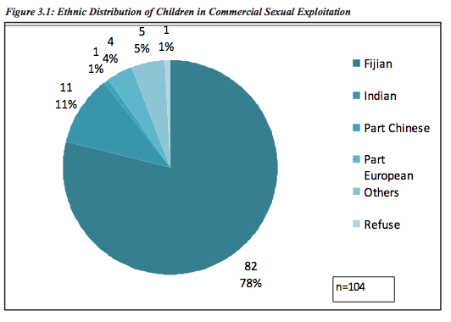
2004 CSEC report – Save the Children Fiji

Save the Children Fiji (2004). The Commercial Sexual Exploitation and Sexual Abuse of Children in Fiji: A situational Analysis.

Fiji ratified the Convention on the Rights of the Child (CRC) in 1993. This CRC protects the interests and rights of children and since its ratification the Government of Fiji and non-government organizations have introduced initiatives (law and policy) in order to reflect the CRC.

Heinous acts against children such as the commercial sexual exploitation of children and child sexual abuse are in direct violation with articles 19, 34, 36.

“It was found that commercial sexual exploitation of children is not restricted to either rural or urban centres. We found there are five types of commercial sexual exploitation of children in Fiji which are: prostitution, pornography, child sex tourism, adoption and early marriage” (pg. 15)

We found in (2006) in our Commercial Sexual Exploitation of Children research that the age of children being used in prostitution were getting younger and younger. (pg 16).

“There is also a general consensus that while girls are the predominant group involved in prostitution an increasing number of boys are becoming involved too”

“The forms of prostitution are both individual and organised (brothel) operations. Brothels mainly exist in urbane enters and are well known to the locals.

“33% of prostitution victims interviewed for this report were found to be still in school and from broken homes”

Push factors:
“Street kids being prostituted as a means of survival, taxi drivers sexually exploiting girls in exchange for transport to school or for a free ride, young people with disabilities supporting themselves and having an independent income. Free alcohol and cigarettes and parental neglect.”

The percentage of the prostitution victims interviewed felt the main reasons they fell into commercial sex work was because of lack of educational and employment opportunities (broken down to each area):

- 67% in Suva
- 76% in Savusavu
- 75% in Nadi
- 60% in Levuka
- 83% in Lautoka

Prostitution is illegal in Fiji but it is hard to prove evidence and legislation tends to target the seller, rather than the buyer.

Any child regardless of ethnicity, location, class or social status was at risk of commercial sexual exploitation.

Risk Factors:

- Poverty of opportunity, education and economics
- Disabled children
- Children from violent homes
- Unsupervised children
- Growing numbers of visitors in Fiji
- Billeted children
- Early marriage
- Displaced families losing source of income (land)
- Demand for child sex drives the industry – without workers and perpetrators willing to pay for it, children would not be in this industry.

Recommendations:

- Reduce poverty – increase access to education
- Generate community awareness to address the issue of Commercial Sexual Exploitation of Children and training of health workers, teachers, and community leaders. Increase children’s knowledge of how to protect themselves and who to tell if they are being abused. Found there is a cultural stigma relating to reporting this so ensure children have a safe space to report it without judgement.
- Empower children in the community by raising their awareness of their rights especially their right to protection.
- Empower parents by raising their awareness of children’s rights as arents have great influence on their children’s lives.
- Lobby Parliament for new laws regarding the sexual defilement of boys.
- Amend current laws being used to prosecute perpetrators who abuse female children” currently; the 2009 amendments for defilement of a female child have different punishments for different ages. For example if a girl is under 13 the maximum sentence for a perpetrator life imprisonment but if the girl is between 13-16 the maximum is reduced to 10 years. SCF recommend these laws are consistent regardless of age.

Crimes Decree 2009
214.1 –defilement - imprisonments for life under the age of 13.
214.2 – attempted – imprisonment for 5 years
215.1 – attempts above 13-16 – 10 years
13-16 yr old –
211.1 – attempts or knows a child under the age of 18 5 years
106.1 – a person who causes another to enter or remain in sexual servitude 15-20 years

